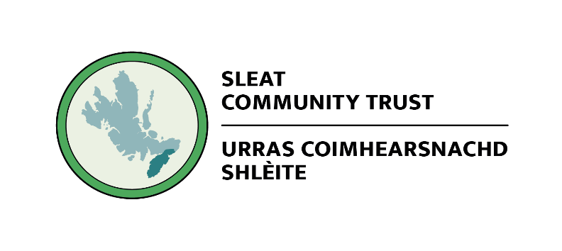

Community Development Officer

Salary | £30,000 per annum pro-rata
Hours | Full time – 37.5 hours per week (part-time or job share considered)
Contract | Subject to SCP funding confirmation
Location | Armadale, Isle of Skye (with flexible working)
Responsible to | Board Chair, Sleat Community Trust
Closing date | June 12 2026
Applications | A CV and covering letter should be sent to: office@sleat.org.uk  Informal enquiries are welcome. Please contact Andy Williamson (andy@sleat.org.uk) in the first instance.

Sleat Community Trust/Urras Coimhearsnachd Shlèite (SCT) is a community-owned development trust working to support sustainable economic, environmental and social development across the Sleat Peninsula in the Isle of Skye. Established in 2003, the Trust has grown from a volunteer-led initiative into an organisation that owns and manages a portfolio of community assets, including:
- Tormore Community Woodland
- Armadale Stores
- SkyeNet Broadband
- VisitSleat

The Trust employs a small team and works alongside volunteers and a committed volunteer boards of directors serving a community of approximately 1,000 local residents. We are proud recipients of the Queen’s Award for Voluntary Service and a global social-purpose tourism award.
We are at a significant point in our development. Our Sleat Renewables trading arm is transitioning away from woodchip operations, a new Long Term Forest Plan for Tormore is close to sign-off, and our community has articulated a clear vision for Sleat’s future through the Local Place Plan.

The Role
The Community Development Officer (CDO) is a new, full-time post that will be the engine of the Trust’s strategic development programme. Working closely with the Board and its Development Group, the CDO will lead on transforming SCT from a grant-dependent organisation into a dynamic, asset-based community development trust generating diversified and sustainable income. This role is funded through the Scottish Government’s Strengthening Communities Programme (SCP) through to March 2029 and is central to how we respond to the community’s vision.

This is not a coordination or administrative post. We are looking for a self-directed, entrepreneurial development professional who can identify opportunities, develop credible project proposals, build relationships within the trust, with partners and with funders, and help the Trust operationalise the priorities set out by the community in its Local Place Plan and elsewhere.
The CDO will work across closely interconnected development areas:
- Building the Trust’s sustainable income stream and growing its asset base
- Enhancing community wellbeing through the generation of new uses for Tormore, including local school groups, community activities and eco-tourism.
- Expanding community enterprise development, including developing a new food network with local producers, assessing enterprise hub feasibility and leading funding applications, project monitoring and funder reporting.
- Strengthening community resilience and supporting renewable energy portfolios
- Supporting the Board’s strategic planning and communications, and develop partnerships with external organisations.

Person Specification
We welcome applications from candidates with a wide range of backgrounds. What matters most to us is drive, adaptability and a genuine commitment to community-led development.

Knowledge and Experience
Essential | Desirable
Proven experience of community or rural development, social enterprise, or project development work | Experience of working with or for a Scottish development trust or community organisation
Track record of developing and securing funding from external sources (grant funding, community finance, or equivalent) | Experience of community asset acquisition or management
Experience of developing business cases, project plans, and financial projections | Knowledge of Scottish land reform, community ownership legislation, and rural policy
Understanding of community development principles and asset-based approaches | Familiarity with renewable energy development processes, particularly community-led schemes
Understanding of the challenges and opportunities facing rural and island communities in Scotland | Knowledge of Gaelic culture and language, or experience working in Gaelic-medium or bilingual contexts

Skills and Abilities
Essential | Desirable
Excellent written and verbal communication skills, including the ability to write compelling funding applications and clear board reports | Experience of community consultation and engagement methods, including in dispersed rural settings
Strong project management skills, with the ability to manage multiple projects at different stages simultaneously | Experience of managing or supporting volunteers
Ability to work effectively with voluntary boards, building productive relationships and supporting governance | Experience of partnership working across statutory, third sector, and private sector organisations
Sound financial literacy and numeracy, including the ability to prepare and interpret project budgets | Experience with woodland, land, or environmental management projects
Self-directed and entrepreneurial approach – able to identify opportunities, take initiative, and work without close supervision | Skills in marketing, communications, or social media

Personal Qualities and Other Requirements
Essential | Desirable
A genuine commitment to community-led development and community ownership | Enthusiasm for the Gaelic language, culture, and heritage of the Western Isles and Highlands
A demonstrable commitment to open, participatory communication and decision making as part of a team
Resilience, pragmatism, and the ability to manage uncertainty – recognising that plans evolve in rural contexts | An interest in environmental sustainability, biodiversity, and climate resilience
Full, clean driving licence and access to a vehicle
Willingness to attend occasional evening and weekend meetings

Terms and Conditions
Salary | £30,000 per annum
Employer pension | 10% employer contribution
Annual leave | 28 days including bank holidays
Working pattern | Full time, 37.5 hours per week. Part-time or job share considered. Flexible working arrangements will be considered
Place of work | Flexible working with a base at the trust officers in Armadale. Regular travel within Skye and Lochalsh is required
Probationary period | 3 months
Notice period | 1 month
Funding | This post is funded through the Scottish Government’s Strengthening Communities Programme (SCP), administered by DTAS. Continuation is subject to ongoing SCP funding

How to Apply
To apply, please submit a CV (no more than three pages) and a covering letter (no more than two pages) addressing the person specification above, explaining what draws you to this role and what you would bring to the Sleat Community Trust.

A CV and covering letter should be sent to: office@sleat.org.uk. Informal enquiries are welcome. Please contact Andy Williamson (andy@sleat.org.uk) in the first instance.

We are committed to equal opportunities and welcome applications from all sections of the community. We particularly encourage applications from people with a connection to, or understanding of, our local area and rural and island Scotland.
Sleat Community Trust is a Scottish Charitable Incorporated Organisation. Charity No. SC035316.

